Cloud Computing Lab

Safa Jahangir
BSE-V B
2023-BSE-056

LAB 06

Task 1 – Switch to root with su - and back to a normal user
- task1_set_root_password.png
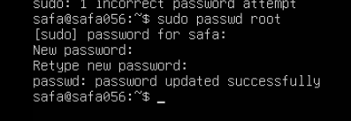
- task1_su_root.png
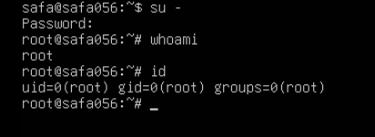
- task1_exit_to_user.png
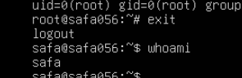

Task 2 – Create user tom and verify in passwd/group/shadow
- task2_adduser_tom.png
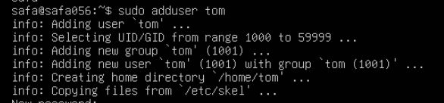
- task2_verify_passwd.png
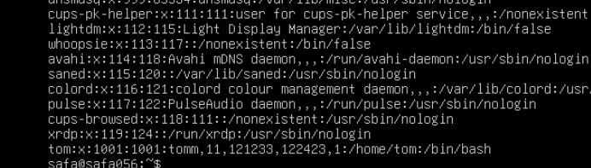
- task2_verify_group.png
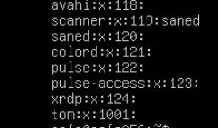
- task2_verify_shadow.png

Task 3 – Create groups; change tom’s primary and secondary groups
- task3_groupadd.png
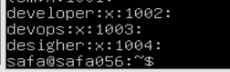
- task3_change_primary_group.png
- task3_add_secondary_groups.png
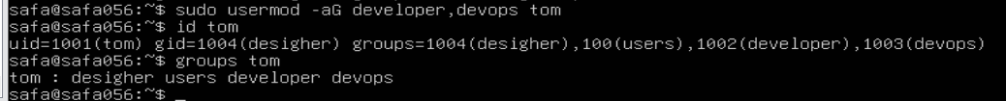
- task3_reset_secondary_groups.png
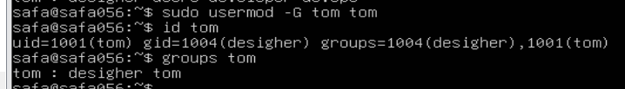

Task 4 – Create/delete users (Jerry, Scooby) and groups (jolly, anime)
- task4_add_users.png
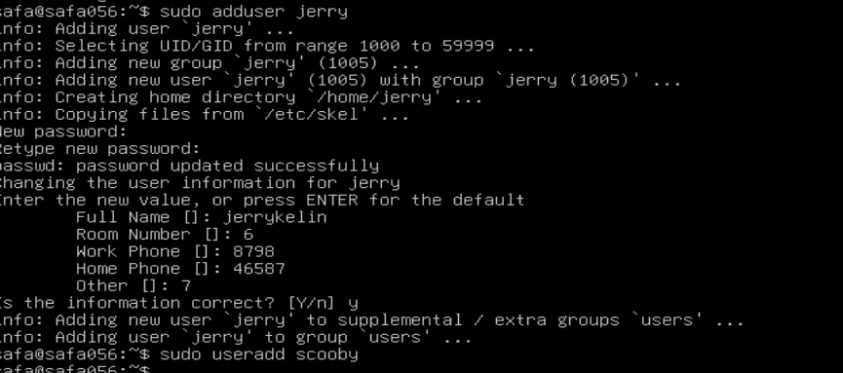
- task4_scooby_su_auth_failure.png
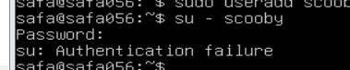
- task4_set_password_scooby.png
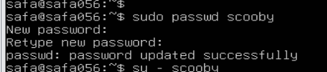
- task4_scooby_su_no_home.png
- task4_scooby_no_home.png
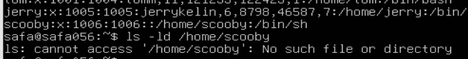
- task4_scooby_create_home.png
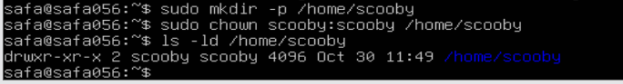
- task4_scooby_login_success.png
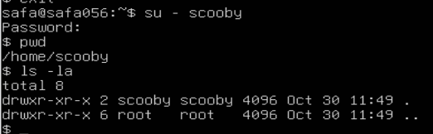
- task4_verify_users.png
- task4_add_groups.png
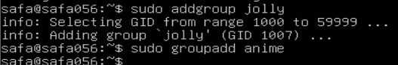
- task4_verify_groups.png
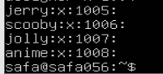
- task4_delete_groups.png
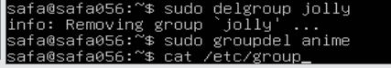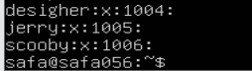
- task4_delete_users.png
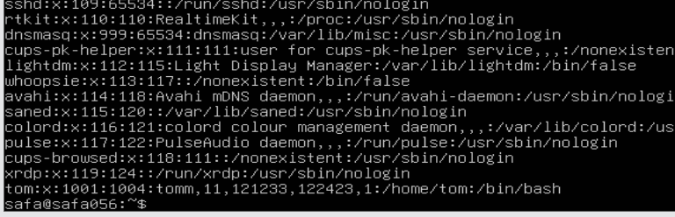

Task 5 – Create user Student; create files; set owner/group; identify file types
- task5_create_student.png
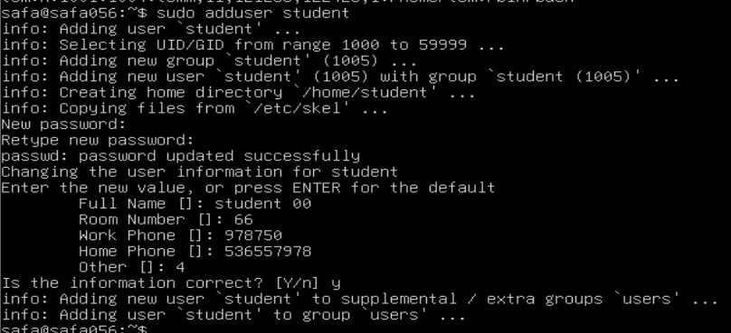
- task5_create_files.png
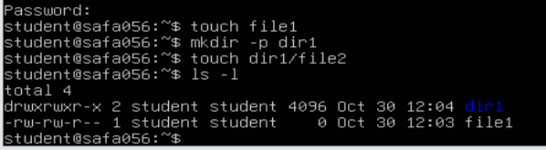
- task5_chown_file1.png
- task5_chgrp_file1.png
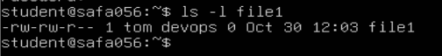
- task5_file_types.png
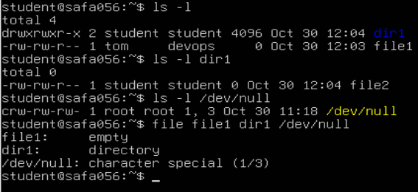
- task5_exit_student.png
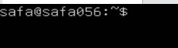

Task 6 – Change permissions using symbolic mode
- task6_su_student.png
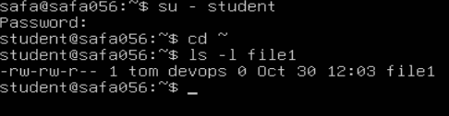
- task6_chmod_remove_rwx.png
- task6_chmod_add_r.png
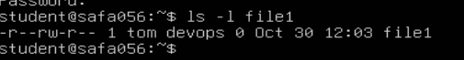
- task6_chmod_u_plus_x.png
- task6_chmod_ug_plus_w.png
- task6_chmod_ugo_minus_rwx.png
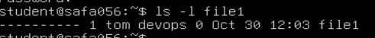

Task 7 – Change permissions using “set” symbolic form (u= g= o=)
- task7_student_context.png
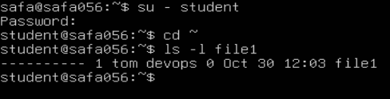
- task7_chmod_set_all_rwx.png
- task7_remove_exec_go.png
- task7_remove_all_perms.png
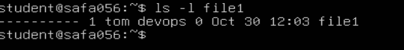

Task 8 – Change permissions using numeric (octal) mode
- task8_student_context.png
- task8_chmod_777.png
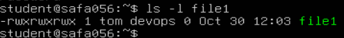
- task8_chmod_700.png
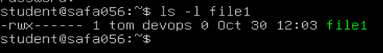
- task8_chmod_744.png
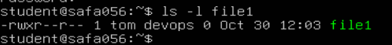
- task8_chmod_640.png
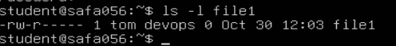
- task8_chmod_664.png
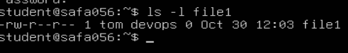
- task8_chmod_775.png
- task8_chmod_750.png

Task 9 – Practice pipes, pagers, grep, and redirects with /var/log/syslog
- task9_grep_less.png
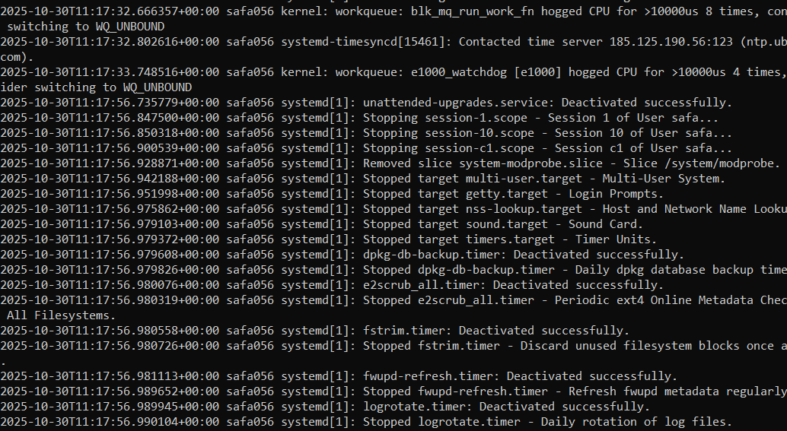
- task9_grep_more.png
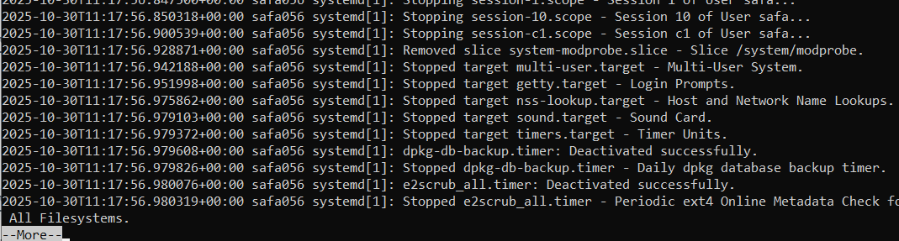
- task9_grep_head.png
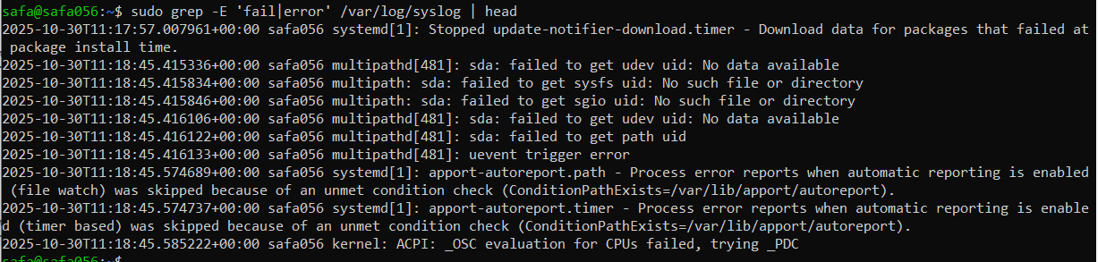
- task9_redirect_overwrite.png
- task9_redirect_append.png
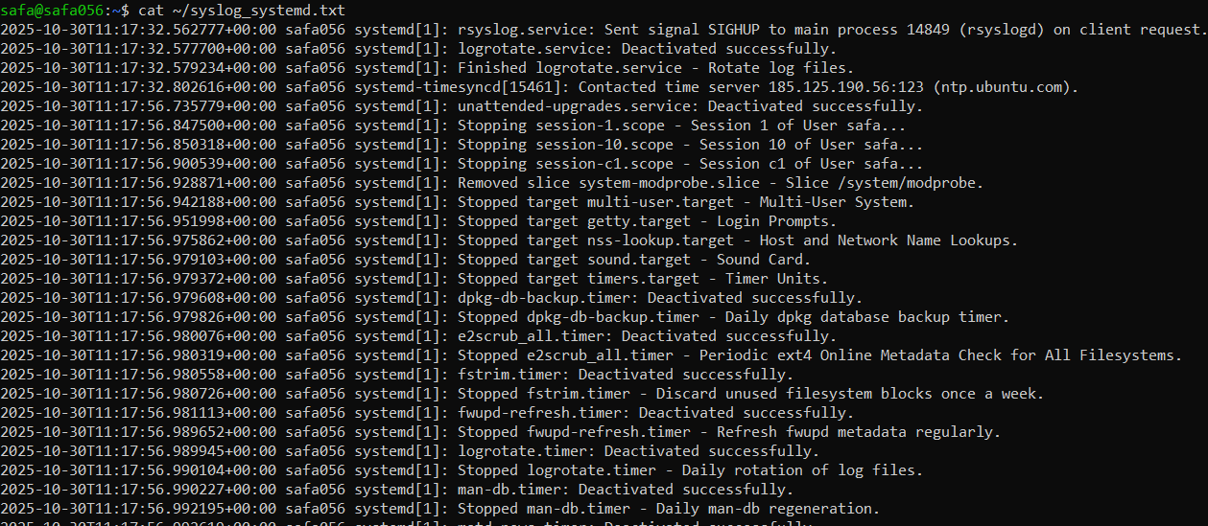
- task9_journalctl_alternative.png
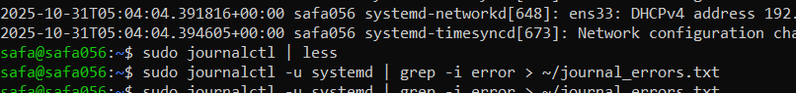

Task 10 – Script setup.sh – variables, command substitution, file/dir checks, permissions (use vim)
- task10_b1_vim.png
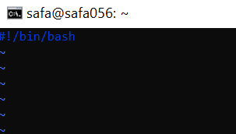
- task10_b1_run.png
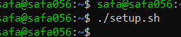
- task10_b2_vim.png
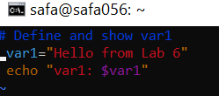
- task10_b2_run.png
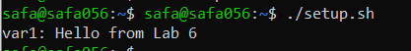
- task10_b3_vim.png
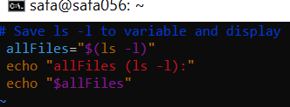
- task10_b3_run.png
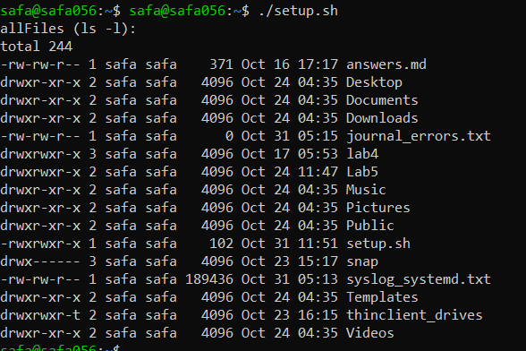
- task10_b4_vim.png
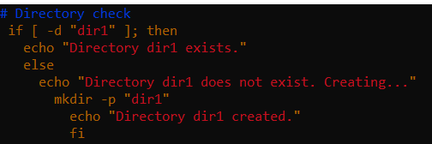
- task10_b4_run.png
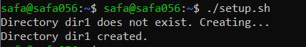
- task10_b5_vim.png
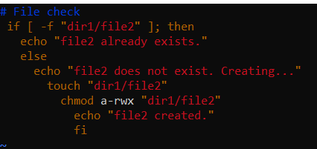
- task10_b5_run.png
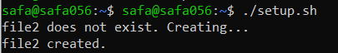
- task10_b6_vim.png
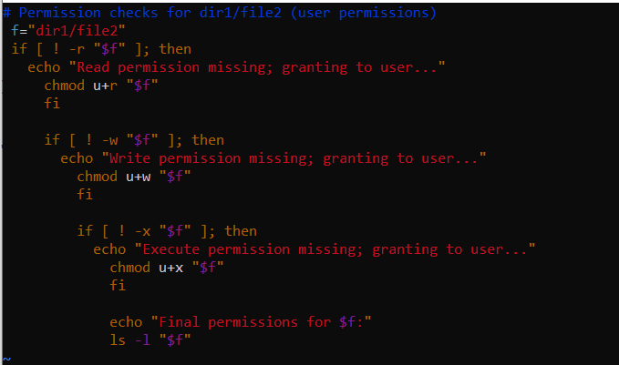
- task10_b6_run.png
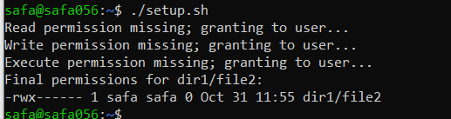

Task 11 – Script setup.sh – argument comparisons (eq, ne, gt, lt, ge, le) and string checks
- task11_b0_vim.png
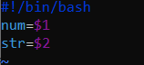
- task11_b0_run.png
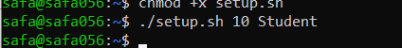
- task11_b1_vim.png
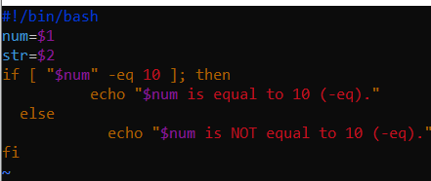
- task11_b1_run.png
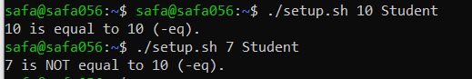
- task11_b2_vim.png
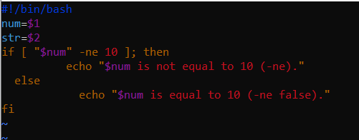
- task11_b2_run.png
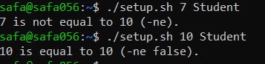
- task11_b3_vim.png
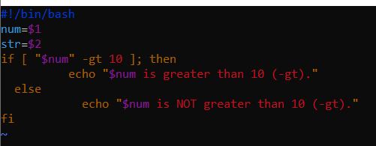
- task11_b3_run.png
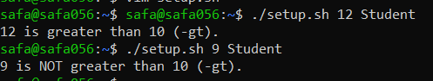
- task11_b4_vim.png
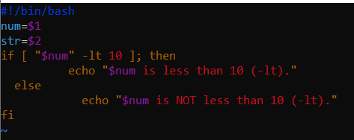
- task11_b4_run.png
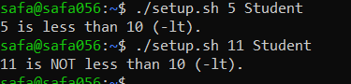
- task11_b5_vim.png
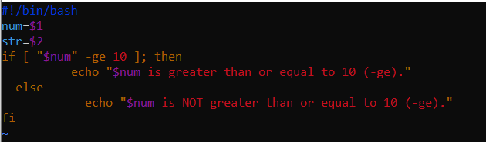
- task11_b5_run.png
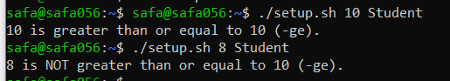
- task11_b6_vim.png
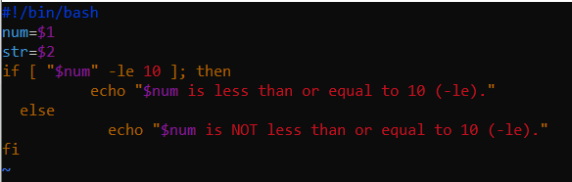
- task11_b6_run.png
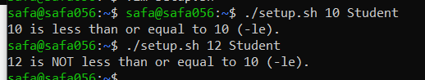
- task11_b7_vim.png
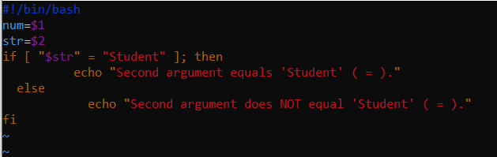
- task11_b7_run.png
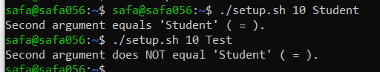
- task11_b8_vim.png
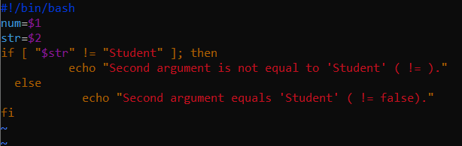
- task11_b8_run.png
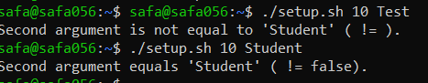
- task11_b9_vim.png
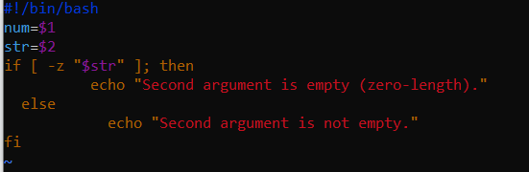
- task11_b9_run.png
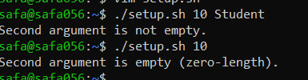

Task 12 – Script setup.sh – print all arguments with a for loop
- task12_b1_vim.png
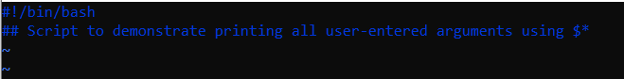
- task12_b1_run.png
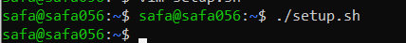
- task12_b2_vim.png
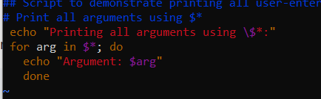
- task12_b2_run.png
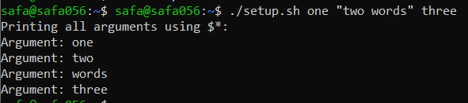

Task 13 – Script setup.sh – while loop summation and functions
- task13_b1_vim.png
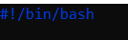
- task13_b1_run.png
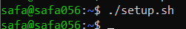
- task13_b2_vim.png
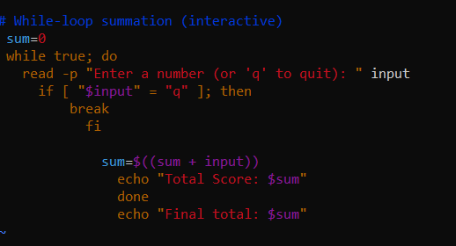
- task13_b2_run.png
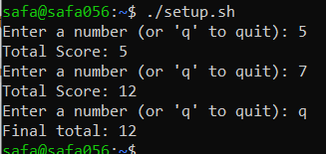
- task13_b3_vim.png
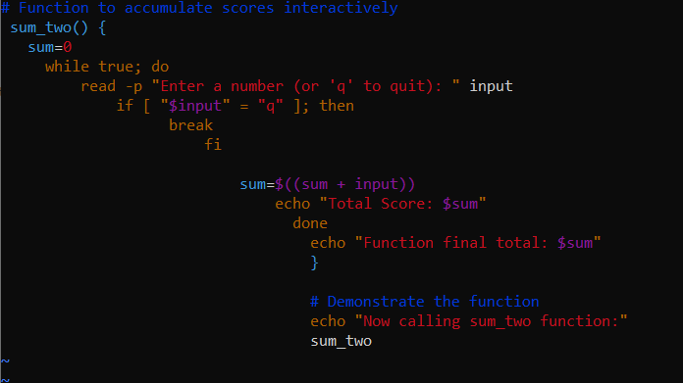
- task13_b3_run.png
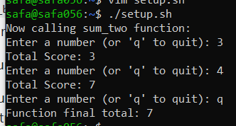
- task13_b4_vim.png
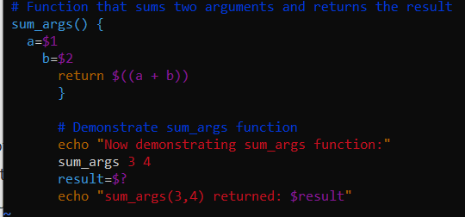
- task13_b4_run.png
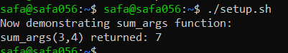

Task 14 – Codespaces GUI — fork repo, run start-desktop.sh, open VNC, stop GUI
- task14_fork.png
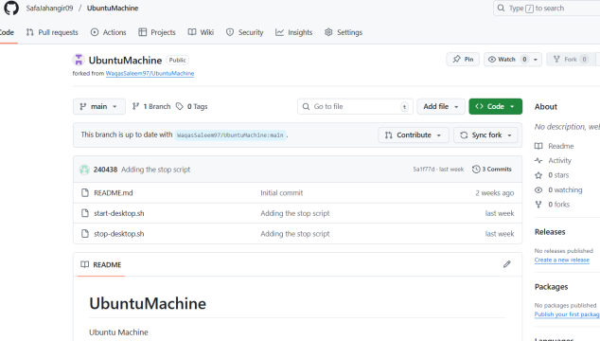
- task14_codespace_launch.png
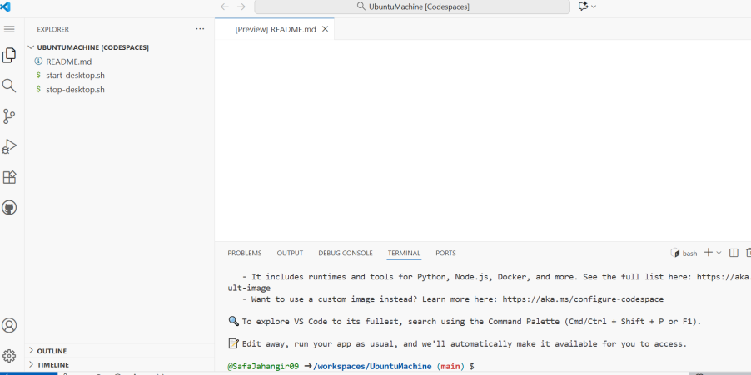
- task14_start_script_ls.png
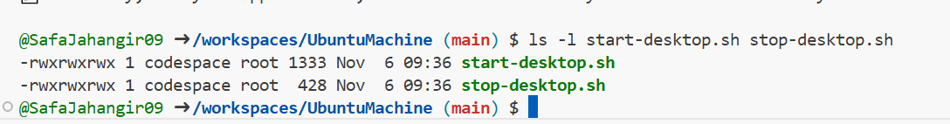
- task14_start_run.png
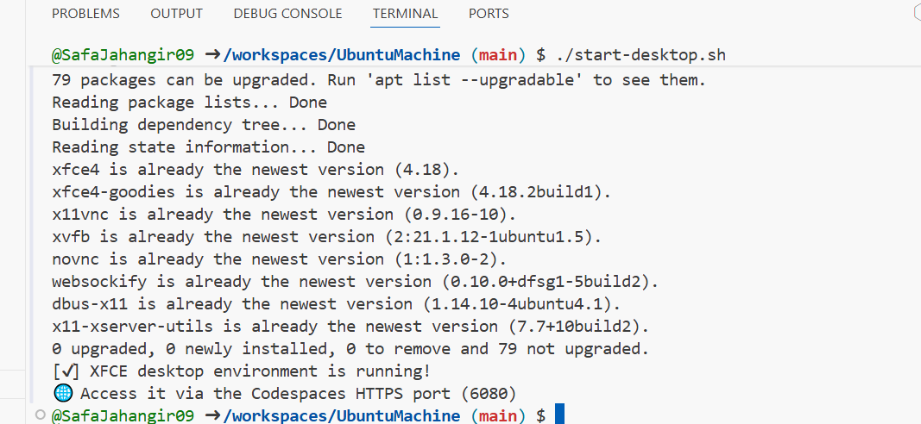
- task14_ports_view.png
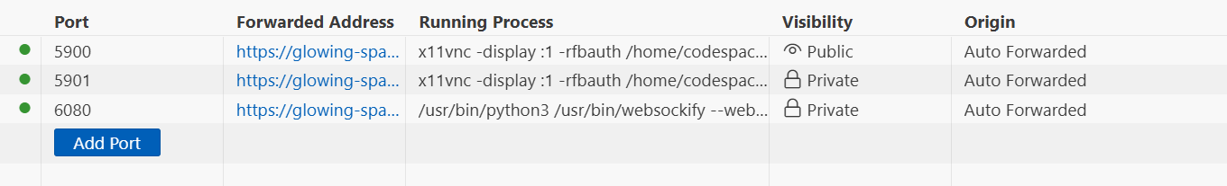
- task14_vnc_url.png
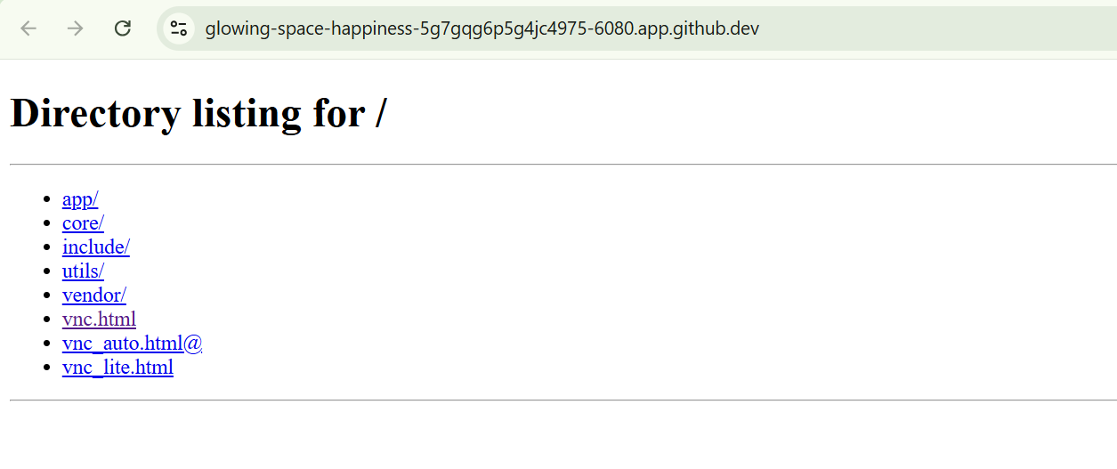
- task14_vnc_password_prompt.png
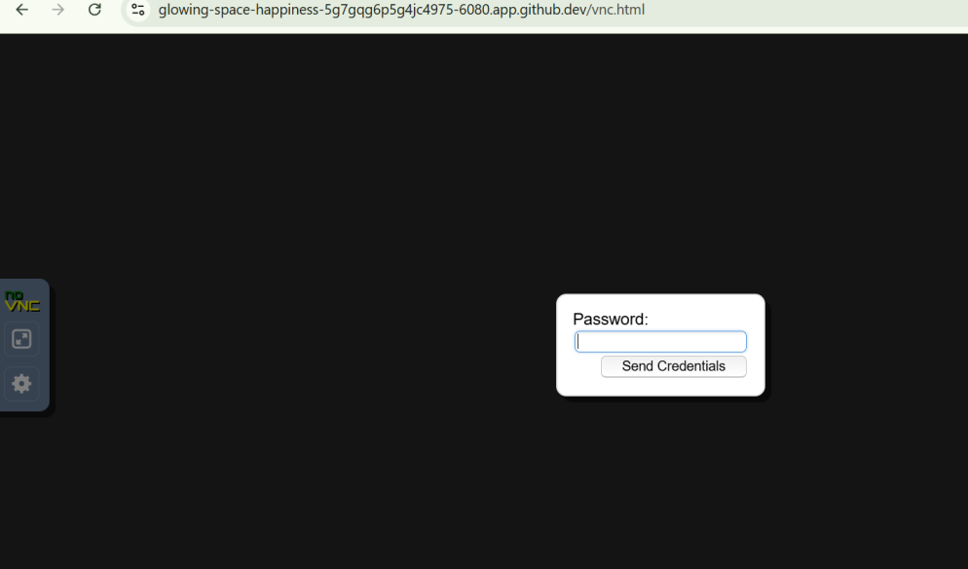
- task14_vnc_desktop.png
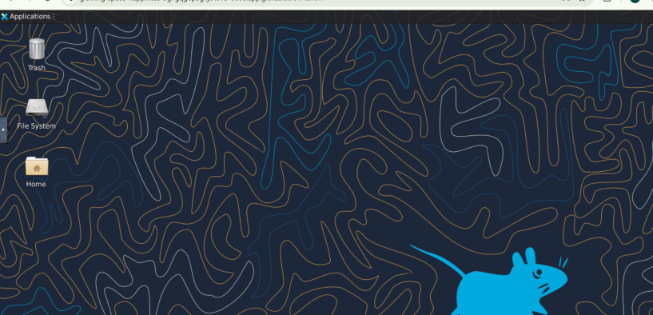
- task14_vnc_connect.png
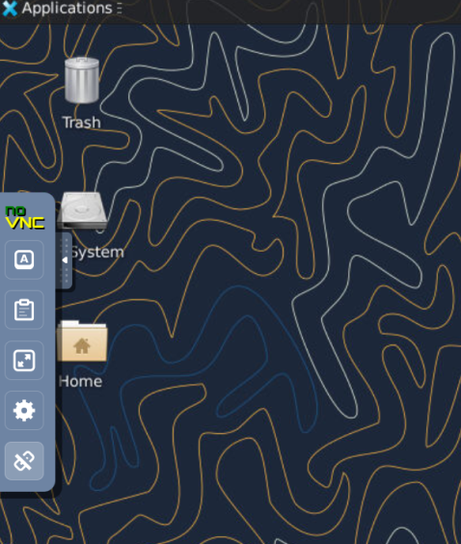
- task14_stop_run.png
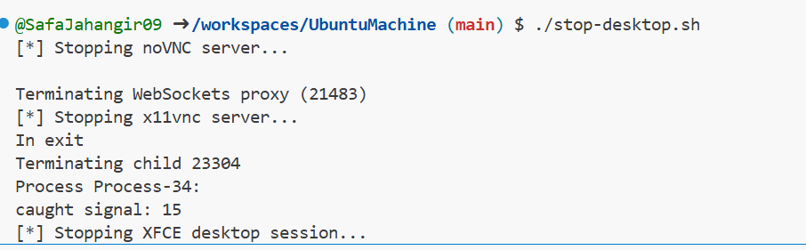

Exam Evaluation Questions

1. Group Management and Membership
Q1_groups_created.png
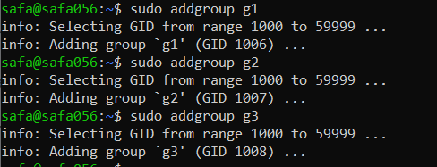
’
Q1_group_changes.png
Q1_group_verification.png
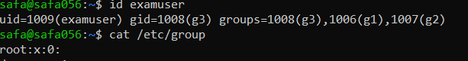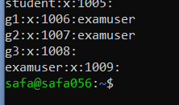

2. Ownership and Permission Tasks
Q2_chown_chgrp.png
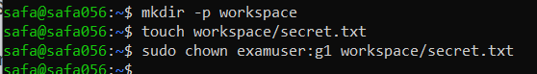
Q2_symbolic_numeric.png
Q2_permissions_ls.png
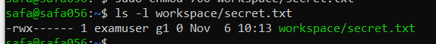

3. Pipes, Grep, and Redirection Practice
Q3_grep_pipe.png
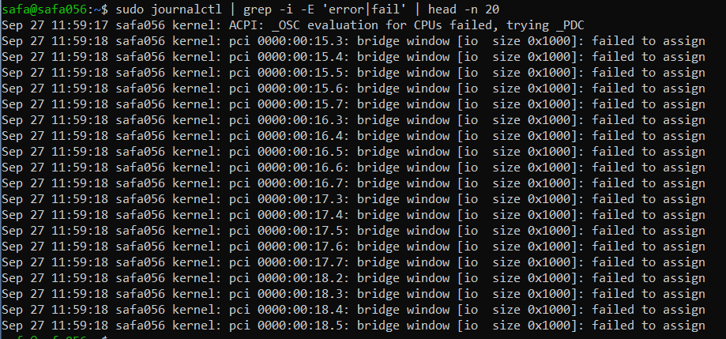
Q3_redirect_overwrite_append.png
Q3_pager_view.png
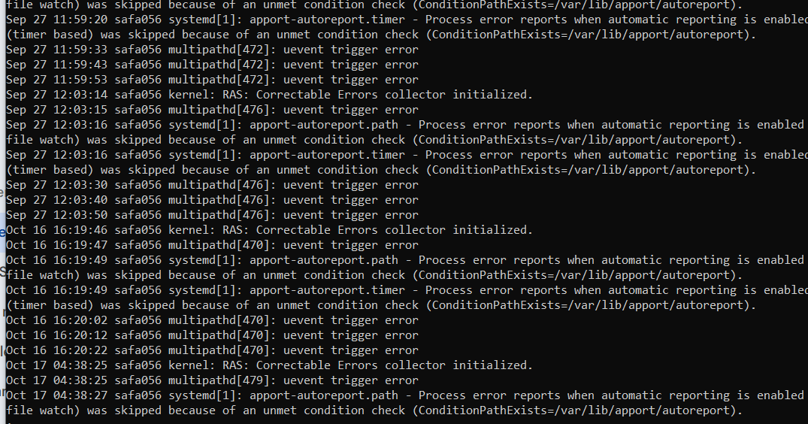

4. Script: Variables, Command Substitution, File & Dir Checks
Q4_step1_var1.png
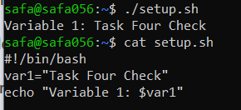

Q4_step2_allfiles.png
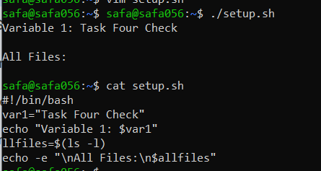
Q4_step3_dirfile_checks.png
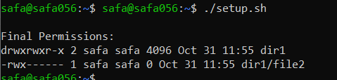

5. Script: Comparisons and String Tests
Q5_eq_examples.png
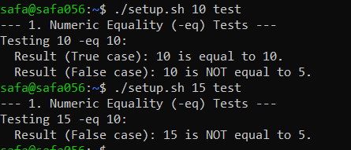
Q5_numeric_tests.png
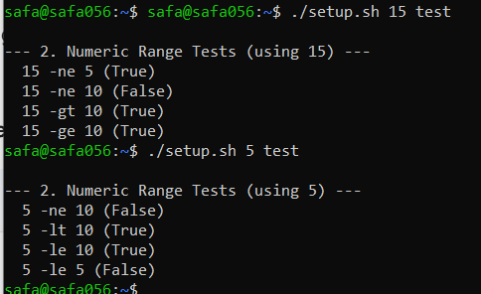
Q5_string_tests.png
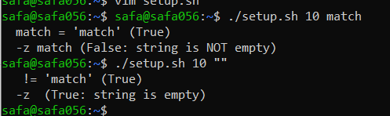

6. Script: For Loop and Argument Handling
Q6_script_forloop_vim.png
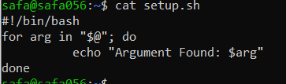
Q6_forloop_run.png
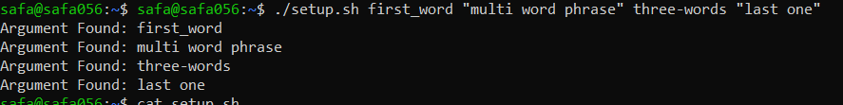

7. Script: While Loop Summation and Functions
Q7_while_session.png
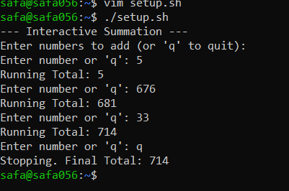
Q7_function_sum.png
